- Before updating the TANF Time Limits Months, re-open the TANF program block using Re-apply for a new application or Rescind as appropriate.
- Navigate to the Time Limit Summary page.
- Click the Name hyperlink for the consumer in the Cash-Aid block.
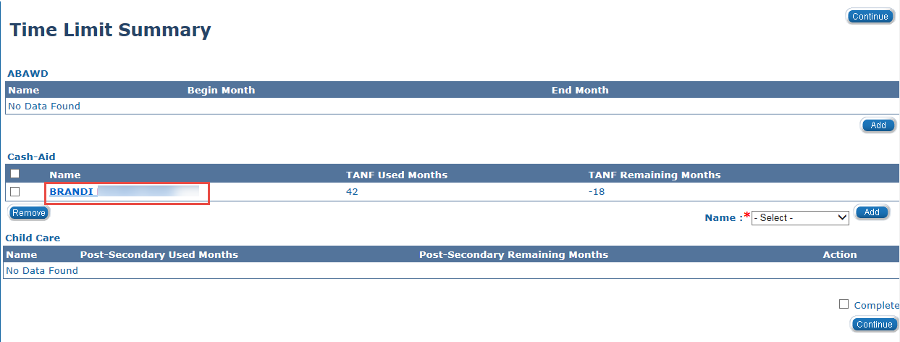
- The Cash Aid Time Limit Month List page displays. Click the Edit button associated to the month you want to update. Best practice is to first remove the most recent TANF months received in Kansas.
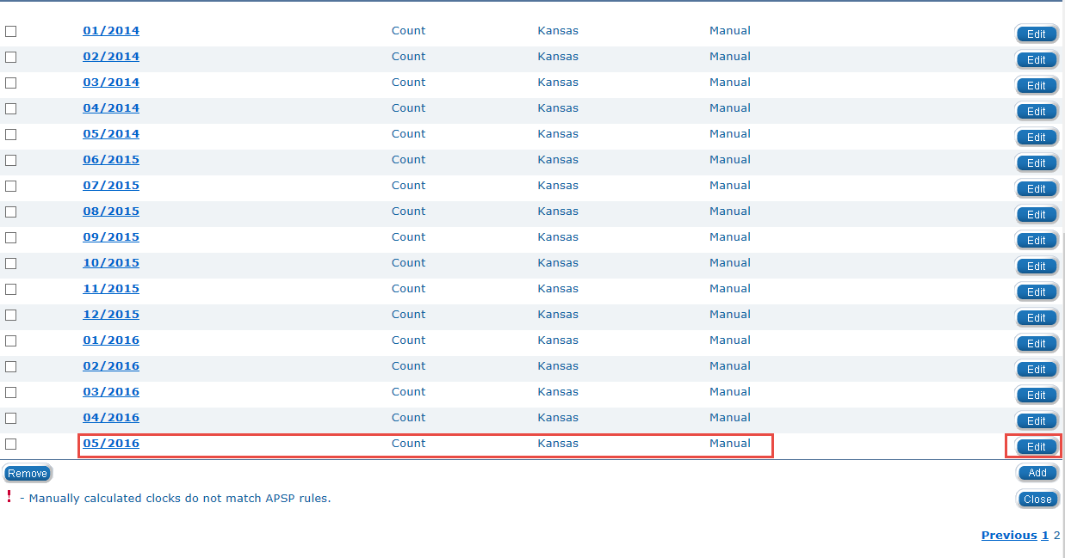

- The Cash Aid Time Limit Month Detail page displays. Change the Add Reason from KEES Month to Manual if Manual is not already selected.
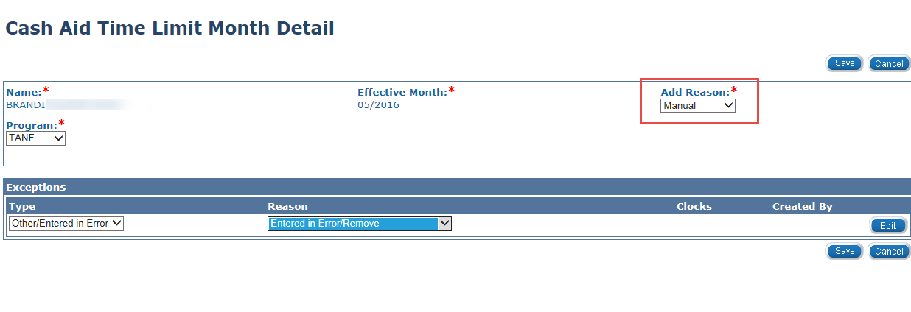
- Select Other/Entered in Error from the Type drop-down menu.
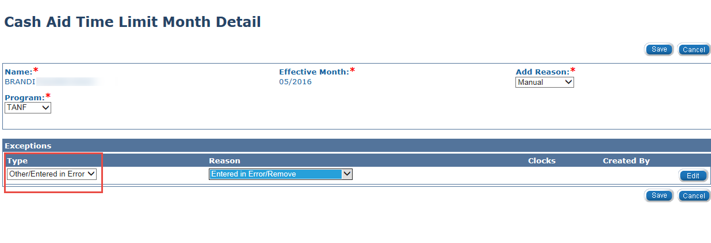
- Select Entered in Error/Remove from the Reason drop-down menu.

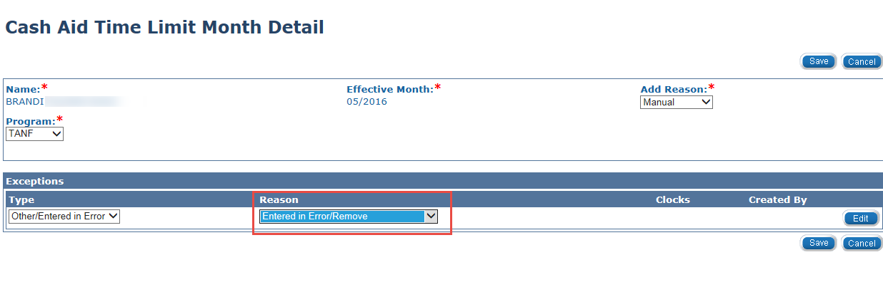

- Click the Save button.
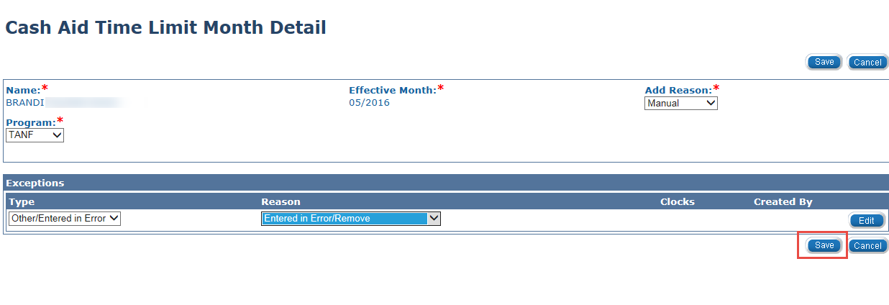
- The Cash Aid Time Limit Month List page displays and the updated month displays as Exempt.
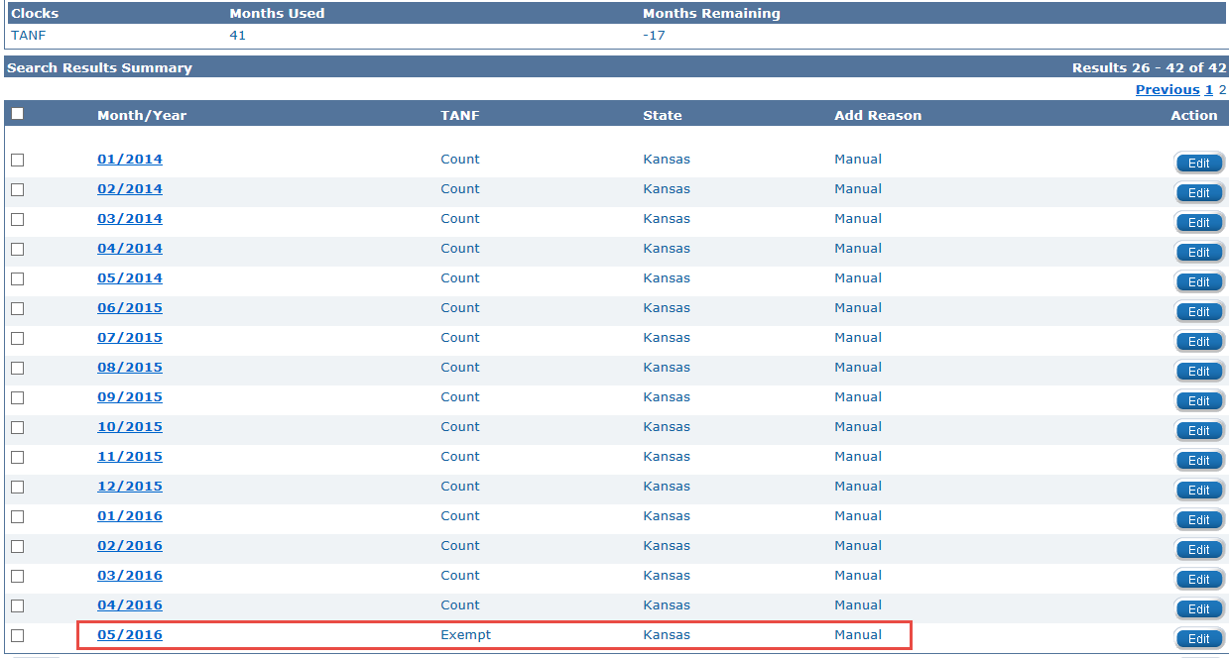
- Repeat the process until the counter reaches 22 months.

